**Technical Documentation – Deploy_Digital_Services**

1. Workflow – Deploys MDSE Business Services Artifacts to an MUAT/Maintenance and IPASP/Production.

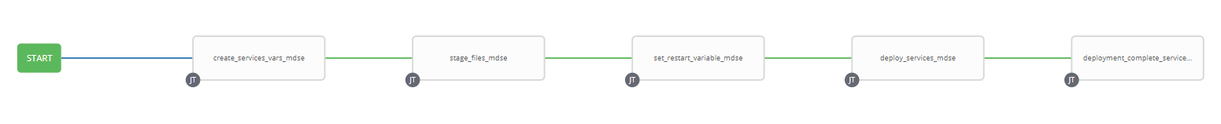

1. Survey – User Supplied Variables

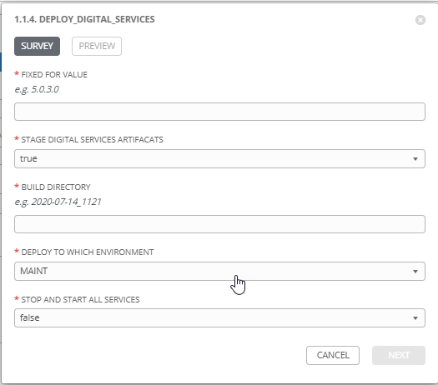

|  |  |  |  |
| --- | --- | --- | --- |
| **Survey Extra Variables** | **Prompt** | **Type** | **Description and Usage** |
| FFV | Fixed For Value | Text | The fixed for value for the deployment – must be of the format ###.###.###.### (i.e. 58.0.12.0). Numbers only, with a maximum of 3 digits and there must be 4 sets separated with a ‘.’. Used to create staging and deployments directories. Used by all job templates in the workflow |
| STAGE | Stage Digital Services Artifacts | Multiple Choice Single Pick | True or false – Copies the Business Artifacts from the MDSE Build Releases Directory to the Staging folder. |
| ReleaseDir | Build Directory | Text | The /pencmw_common/MDSE/releases/ subdirectory that contains the business services artifacts |
| ENV | Deploy to Which Environment | Multiple Choice Single Pick | The Environment to Deploy to: MAINT or PROD. Only a single environment can be deployed to per workflow execution |
| SERVICES_RESTART | Stop and Start All Services | Multiple Choice Single Pick | True or false – Restarts ALL MDSE Services. |

1. Jobs Used by the workflow - http://owl.penc.local:18080/svn/deploy_automation/trunk/Ansible_PlayBooks/MDSE

| **Job Template** | **Ansible Playbook** | **Credentials / host** | **Project** | **Description and Usage** |
| --- | --- | --- | --- | --- |
| create_services_vars_mdse | create_services_vars_mdse.yml | None – runs on localhost as awx linux user | MDSE Deployments | Creates Variables/Artifacts for use within the workflows, based on the User supplied survey results.  Artifacts Defined with examples  DeploymentLogDir: /codemove_common/dp_automation/deployments/001.000/001.000.004.000/MDSE  RESTART_ALL: false  StageDir: /codemove_common/dp_automation/stage/001.000/001.000.004.000/MDSE  date_time: '20200901_1447'  services_deployment_host: 'mbusserv3bcp,mbusserv4bcp'  stage_server: diagoras1bcp  tower_hostname: pdeploy1bcp.penc.local |
| stage_files_mdse | stage_files_mdse.yml | codemove on {{stage_server}} – typically diagoras1bcp | MDSE Deployments | Copies MDSE Services Artifacts from /pencmw_common/MDSE/releases/{{ReleaseDir}} to the {{StageDir}}/{{ReleaseDir}}  The job fails if the /pencmw_common/MDSE/releases/{{ReleaseDir}} build directory does not exist.  If the stage_server is set to ‘none’ as opposed to diagoras1bcp, the playbook does not do anything, all of the tasks are skipped.  The last task of the job creates a Staging Report in the {{DeploymentLogDir}} in html format. |
| set_restart_variable_mdse | set_restart_variable_mdse.yml  calls:  check_for_key_jars_mdse.yml | None – runs on localhost as awx linux user | MDSE Deployments | Loops through all the jar files in {{StageDir}}/{{ReleaseDir}} with the check_for_key_jars_mdse.yml playbook and if any jar file is one of penc-config-srv.jar, penc-hub-srv.jar, penc-security-srv.jar or penc-gateway-srv.jar set the {{RESTART_ALL}} to true.  If the User has set {{SERVICES_RESTART}} to true set {{RESTART_ALL}} to true. |
| deploy_services_mdse | deploy_services_mdse.yml  CALLS:  shutdown_mdse_services.yml when {{RESTART_ALL}} is true  deploy_single_service_mdse.yml  startup_mdse_services.yml when {{RESTART_ALL}} is true | pencmw on {{services_deployment_host}}  such as mbusserv3bcp, mbusserv4bcp | MDSE Deployments | deploy_services_mdse.yml, if {{RESTART_ALL}} is true, it stops all of the services with specific shutdown tasks for the gatewayservice, securtiyservice, hubservice and configserve, then calls shutdown_mdse_services for all other services.  deploy_services_mdse.yml then calls deploy_single_service_mdse.yml by looping through the jar files in {{StageDir}}/{{ReleaseDir}}. If {{RESTART_ALL}} is false the service will be stopped, deployed and then started. If {{RESTART_ALL}} is true all of the services have already been shutdown so the jar file is just deployed.  If {{RESTART_ALL}} is true deploy_services_mdse.yml, starts the configservice, hubservice, securityservice and gatewayservice in a specific order. It also checks ports 18000 and 18001 to ensure the config and hub services are started before proceeding. If {{RESTART_ALL}} is true it then calls startup_mdse_services.yml to start the rest of the services.  The playbook operates in serial mode so it deploys to a single server at a time (i.e. no outage in a load balanced environment) |
| deployment_complete_services_mdse | deployment_complete_services_mdse.yml | pencmw on pdeploy1bcp set in playbook | MDSE Deployments | Populates an html formatted deployment log {{DeploymentLogDir}}/{{ReleaseDir}}/{{ENV}}_MDSE_{{date_time}}.html |